FEEDBACK

# Task 1 for M1

Various features of PHP server side programming and MySQL database system has been already discussed. Now this paper further evaluates each features by accessing their benefits and limitations while developing web application. This will enable to evaluate functions and advantage of web application.

# Evaluation of PHP5

PHP scripting language allows developer to produce fast and dynamic website and is an open source as well as platform independent server side scripting tool. To further evaluate PHP5 it has been analyzed with older versions of PHP below as well as latest PHP 7.0.0 is also thoroughly discussed while evaluating limitations of programming with PHP language.

## PHP5 VS older PHP versions

According to PHP dot net (n.d.) Incorporated Zend Engine 2 and PHP 5 has extraordinarily enhanced PHP’s execution and capabilities performance, however great consideration has been applied to support existing code as much as possible. Most of the existing codes from PHP 4 can easily be supported in PHP 5 without considerable changes to keep the web application running without problem however some of the code requires modification. It is must to test existing code before migrating and publishing application with new version of PHP. PHP5 greatly improve three key aspects; OOP support, XML support and MySQL support. Key changes in PHP 5 compared to PHP4 and older PHP versions are as follows:

|  |  |  |
| --- | --- | --- |
| **Comparison Criteria** | **PHP 5** | **PHP 4** |
| Constructors | Constructors are created using _construct() and Destructors as _destruct() | Constructors are created using same name of the class |
| New Keywords | PHP supports new keywords such as finally which is very useful feature while dealing with error/exception handling Ahsan (2013). Codes inside finally block always gets executed regardless of occurrence of exception events. Other new keywords includes callable, goto, insteadeof, yield and trait. These new keywords offers greater flexibilities to programmers. | |
| Abstract | Creating abstract class is possible | Does not support abstract class |
| Access modifier | Supports OOP concept of Access modifier i.e. public, protected and private offering greater security choices to programmer | Does not support access modifier |
| Expectation Handling | Introduces exception handling | Does not support exception handling |
| XML Support | Trachtenberg (2004) writes, PHP5 greatly improves support to XML with new XML extension. While PHP4 was able to manipulate XML, PHP 5 enhances XML support and fixes issues with PHP4 XML support. Reading and modifying XML data is much easier and reliable with PHP5. | |
| MySQL Support | MySQL has been true database system support for PHP programming for ages. With PHP5 version it further improves support for MySQL with new features and OOP support. With inclusion of my_sqli, it allows to provide object oriented interface to MySQL. | |
| Iterators | One of the other key advancement of PHP5 over its predecessor is presence of for-each iteration. It allows to greatly improve coding structure by getting rid of messy condition checking inside of while loop. | |

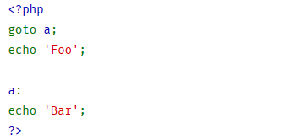PHP 5 is vast improvement from PHP4. It offers highly compliant HTML output due to its compliance with latest W3C specification of HTML and XHTML. PHP5 also ensures greater support for data handling with MySQL and XML with new MySQL and XML extension mechanism. Introduction of Java and C++ type exception handling i.e. try-catch-finally enables programmers to track and handle error with more flexibility. PHP5 allows to program neat and managed codding structure. And other advancement of PHP5 is introduction of keywords such as goto (Bhumi, n.d.). Goto operator allows to jump to another section of program as show in figure 1. It is not a significant advancement though it offers programmers with greater flexibility. In example (figure 1) code execution jumps to section a: and prints Bar as output.

Figure 1 Goto Statement

# Evaluation of PHP5 features

## Object-Oriented PHP

## Evaluation of Polymorphism

Polymorphism offers programmers ability to use single name for different functionality and is a fundamental concept in OOP. By utilizing this feature of OOP in PHP, programmer can create different functions that has similar name but offers dissimilar performances. Two of the core aspects of Polymorphism are Interfaces and Abstract classes.

## Interfaces

Interfaces are very similar to normal classes but it has unique feature that it itself cannot carry code, Guidetti (2010). It has ability to define methods and their arguments but cannot define contents of the method. Interface is in OOP is utilized by programmer to set rule for class. By implementing interface programmers can impose class to declare definite set of methods. Interface is utilized as architectural map in OOP based application. In PHP, ‘interface’ keyword is utilized to declare an interface as shown in figure 2.

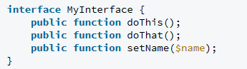

Figure 2 Declaring interface (Source: http://code.tutsplus.com)

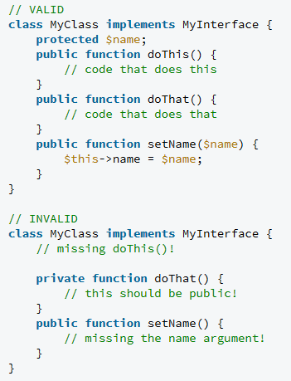This interface can be enforced to other class utilizing ‘implements’ keyword and servers as rule map for the class. Class on which interface in implemented must declare classes that are in interface as shown in figure 3. In example figure 3, all methods are declared exactly as in interface which is valid practice while in figure 4, dothis() method is missing in class which is not allowed.

Figure 3 Invalid interface implementation (Source: http://code.tutsplus.com)



Figure 4 Valid interface implementation (Source: http://code.tutsplus.com)

## Abstract Class

Core difference with normal class is abstract class cannot be instantiate, writes hunter (2009). Abstract class is somewhere between interface and normal class. Singh (2013) notes core difference between abstract class and interface is that in interface each the methods are just abstract methods whereas in abstract class it is not completely necessary. Abstract class can contain content codes as well as abstract methods while interface does not include content codes. As show figure 5, ‘abstract class’ keyword is utilized for declaring abstract class.

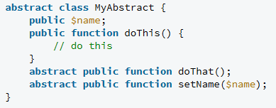

Figure 5Declaration of abstract class (Source: http://code.tutsplus.com)

To implement an abstract class on other class, ‘extends’ keyword is utilized as shown in figure 6. Similar to interface, each methods in abstract class must be declared in enforced class.

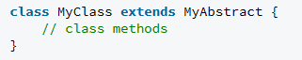

Figure 6 Implementation of Abstract class using extends (Source: <http://code.tutsplus.com>)

# Access Modifier

**In Object oriented PHP, to control visibility of any class member such as properties and methods, access modifier is utilized. According to PHPPOINT (n.d.) there are three types of access modifier scope in PHP5. And they are public, private and protected. Each scope defines different level of visibility of class members. Each access modifier types are analyzed below.**

## Private

Similar to other programming languages such as Java or C++ OOP, PHP5 utilizes private access modifier to limit access to class members. Anzala (2013) describes it as scope to hide data from user. Class members associated with private scope are only accessible from inside the class. No other class can access them hence it hides members from outside class. In figure 7, use of private scope is demonstrated. All private members are only accessible from inside class, in example figure 7) function specification () is associated with public scope hence can be called from another class. However $Model is associated with private scope hence from outside it cannot be called.

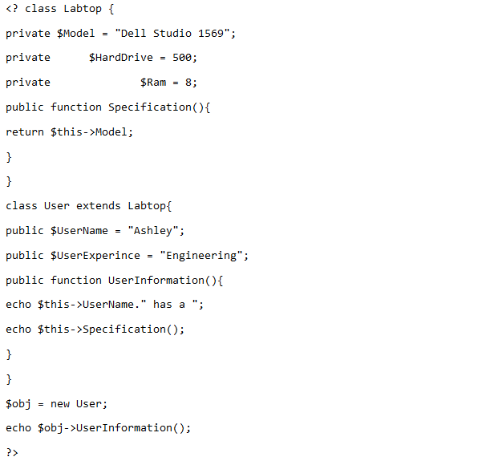

Figure 7 Demonstration of Public and Private access modifier (Source: http://www.trustingeeks.com)

## Public

As the name suggests, public access modifier allows class members to be public and enable anyone to access them. Class member (properties or methods) can be accessed from inside class using $this🡪property or method name. According to Itsphptutorial (n.d.) it sets members to be accessed from inside as well as outside the class definition. It can be accessed in child class and out of the class utilizing instance with 🡪 property or method name. This scope is implemented when member is required to be open to anyone. In example (Figure 8) use of public access modifier is illustrated. $name is access from inside class using $this🡪 name; and from outside it is access using instance $user_A🡪 name; It shows public access modifier can be access from inside and outside of class.

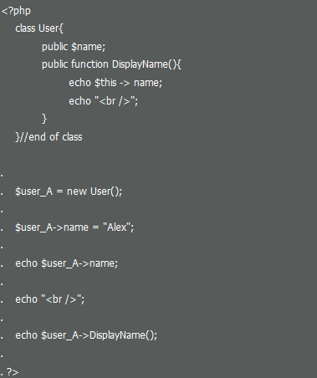

Figure 8 Example of Public access modifier (Source: https://itsphptutorial.wordpress.com)

## Protected

Protected access modifier is utilized to limit access to class members allowing access from only inside of classes or from subclasses. PHPPOT (n.d.) notes it is used in PHP scripting language where inheritance concept is implemented. In example (figure 9) below illustration of protected scope is provided. Members with protected access modifier in example can be accessed from inside the class or from its subclasses only. In example $Name is protected and is access from subclass Display using $this🡪Name; However, $Name cannot be access from outside class.

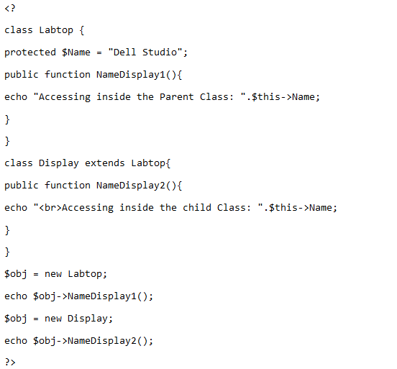

Figure 9 Example of protected access modifier (Source: http://www.trustingeeks.com)

## Use of Access modifier

Access modifier are utilized as a fundamental module of data hiding and encapsulation (SUNILB, 2007). Use of these access modifiers discussed above protected, private and public allows programmer to control visibility of class members from inside and outside the class.

# Magic Methods in PHP

The "magic" systems are ones with unique names, beginning with two underscores, which signify routines which will be activated because of specific PHP occasions. It allows programmers to do special things, PROGRAMMERINTERVIEW (n.d.). That may sound marginally auto magical all things considered it's really clear. Magic methods in PHP are some predefined capacity by PHP compiler which executes on some occasion. Magic methods begins with prefix __, for instance __call, __get, __set. There are various magic methods in PHP. Here this paper will analyze about the absolute most common magic methods for PHP which will be used in object oriented programming. According to Singh (n.d.) some of the magic methods are __Construct, __Destruct, __isset, __unset, __call, __callstatic, __sleep and __wakeup etc.

## __Construct

The constructor is a magic method that gets called when the class is instantiated. It is normally the first thing in the class announcement however it doesn't should be, it a strategy like some other and can be pronounced anyplace in the class, LORNAJANE (2012). Constructors likewise acquire like whatever other technique. This magic method is called when somebody make object of your class. Generally this is utilized for making constructor as a part of php5.

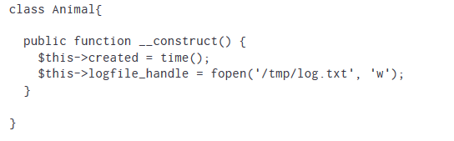

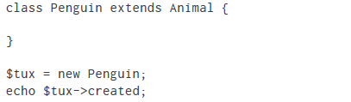

Figure 10 Example of __Construct (Source: http://www.lornajane.net)

## __Destruct

This magic method is utilized for opposite action of __Construct. It is executed when object is destroyed. It can be done manually or not using the object anymore. Figure 11 demonstrates example of use of __Destruct.

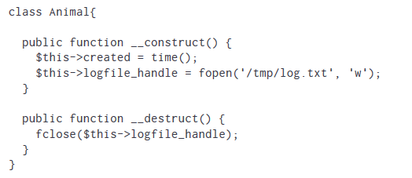

Figure 11Example of __Destruct (Source: http://www.lornajane.net)

# Session Handlers

Session are an apparatus which offers the web developer some assistance with overcoming the stateless way of the web. Programmers can utilize them to manufacture shopping baskets, screen visits to a site, and even track how a client explores through your application (Smith, 2011). PHP's default session taking care of conduct can give everything programmer need by and large, however there might be times when programmer need to grow the usefulness and store session information in an unexpected way. It is useful to see how PHP stores session information typically. The information is spared in a little document on the server which is connected with unique ID which is then put away in a treat on the customer by the program. In the event that treats aren't utilized, the ID is normally gone along as a parameter in the URL. Whichever strategy is utilized, PHP recovers the session information in ensuing page demands utilizing the session ID. Programmer can check and set session save path or check session using following example codes.

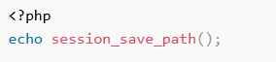

Figure 12 (Source: http://www.sitepoint.com/)



Figure 13(Source: http://www.sitepoint.com/)



Figure 14(Source: http://www.sitepoint.com/)

Location of session save path can easily be altered using PHP.ini by administrator as well can be altered using script shown in figure 12. On the off chance that developer needs to set an alternate registry in which to store session information, it's a decent practice to pick an area that is outside root web catalog as this can lessen the danger of somebody capturing a session. Software engineer need to ensure that they have given the registry sufficient consents to be perused from and composed to by the server.

## Start Session

Session_start() function is utilized to start new session is there is no existing session available. If session is already available, it continues existing one. According to W3School (n.d.) $_Session is used for storing session variables. As shown in example (figure 15) below, session_start() has started a new session and session variables are set using $_session keyword.

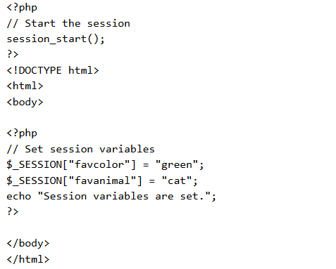

Figure 15Example of Session_start () and $_Session (Source: http://www.w3schools.com/php/php_sessions.asp)

## Destroy Session

To uproot all global session variables and decimate the session, session_unset() to remove all session variable and session_destroy method to destroy session are utilized as shown in figure 16.

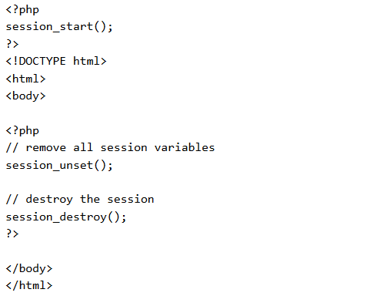

Figure 16 Example of Session Destroy (Source: http://www.w3schools.com/)

## PHP’s isset function

Since we can store and recover information from the $_SESSION exhibit, we can investigate a portion of the genuine usefulness of sessions. When programmer make a variable and store it in a session, programmer presumably need to utilize it later on. Notwithstanding, before they utilize a session variable it is fundamental that you verify whether it exists as of now. According to Tizag dot com (n.d.) this is the place PHP's isset capacity proves to be useful. isset is a capacity that takes any variable programmer need to utilize and verifies whether it has been set. That is, it has as of now been relegated a worth. In example (figure 17) below, isset function is utilized to check whether session variable views exists or not. This helps to reduce unnecessary complications.

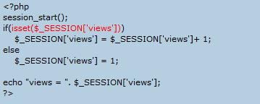

Figure 17 Example of use of isset function (Source: Tizag.com) (Source: http://www.tizag.com/phpT/phpsessions.php)

## Use of Session

There are various use of session, some of the fundamental use of session are listed here below:

1. It helps to reduce number of login at single time (Moon, 2011). Case in point if application ought to permit just 10 logins at once, then the session table can be checked to locate the quantity of clients as of now signed in. In the event that the cutoff is surpassed, then further clients may not be permitted to sign in.
2. It allows administrator to monitor activity of a user in web application. It enables to View which client is right now on the web, when he login and for to what extent has he been dynamic.
3. It helps to ensure that one user can login from one place at one time. In the event that site or application needs to make a client login from just one area at once for security reason or something else , then the sessions table can essentially erase the prior session information of a specific username and login the new one.
4. Finally, it allows programmer to set definitive timescale for user inactivity then programmer will automatically make that user logout from the application. This will help to enhance security. To do this, simple, session entry is removed from database after predefined time of inactivity.

## Cookies

A cookie is a little bit of content put away on a client's PC by their program. Regular uses for cookies are server session identification, site preference storage, shopping cart items, and preference etc. According to Lassosoft (n.d.) every time the clients' web program interfaces with a web server it will pass the treat data to the web server. Just the cookies put away by the program that identify with the space in the asked for URL will be sent to the server. This implies cookies that identify with www.example.com won't be sent to [www.exampledomain.com](http://www.exampledomain.com).

A basic component in web writing computer programs is the capacity to flawlessly pass information starting with one page stack then onto the next. It's utilized most usually when managing client logins, additionally to pass mistake messages, shopping baskets, and so on. Putting away information crosswise over pages utilizing PHP is finished with two variables in the global scope, called $_SESSION and $_COOKIE, and in spite of the fact that achieving the same deciding objective, the both go about it in altogether different ways (Muse, 2010). The distinction is in how every store information. Cookies store information locally in the client's program, while sessions store information on the webserver.

## Session over Cookies

One of the key reason of selection of session over cookies is its nature to store data in server. Sessions are put away on the server, which implies customers don't have admittance to the data programmer store about them - this is especially critical on the off chance that programmer store shopping carts or other data programmer don't need their guests to have the capacity to alter by hand by hacking their cookies, HACKINGWITHPHP (n.d.). Session information, being put away on your server, does not should be transmitted with every page; customers simply need to send an ID and the information is stacked from the neighborhood record. At long last, sessions can be any size you need on the grounds that they are hung on your server, though numerous web programs have a point of confinement on how huge cookies can be to stop maverick sites biting up gigabytes of information with negligible treat data.

# Web Services

Two of the main web services are SOAP and RESTful that PHP supports.

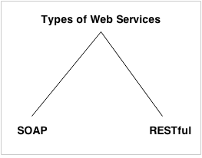

Figure 18 Types of Web services (Source: http://www.javatpoint.com/what-is-web-service)

## SOAP

SOAP is XML based convention. It is stage autonomous and dialect free. By utilizing SOAP, developers will have the capacity to cooperate with other programming dialect applications. According to PACKTUB (n.d.) SOAP, in the past known as Simple Object Access Protocol (until the acronym was dropped in variant 1.2), came around not long after XML-RPC was discharged. It was made by a gathering of designers with sponsorship from Microsoft. Interestingly, the inventor of XML-RPC, David Winer, was additionally one of the essential supporters to SOAP. Winer discharged XML-RPC before SOAP, when it got to be obvious to him that however SOAP was still a path far from being finished, there was a prompt requirement for some kind of web administration convention.

HTTP is utilized as component to talk in the middle of customer and servers by sending POST asks for with XML ask for and reaction bodies (Whitewashing, 2014). The SOAPServer and SOAPClient objects ship with PHP center naturally. Developer can uncover capacities, classes or questions as server by enrolling administration callbacks with SOAPServer#addFunction, SOAPServer#setClass or SOAPServer#setObject and after that calling the handle () technique, which handles demand and reaction era and sending in one stage. Developer can ordinarily leave the solicitation straightforwardly after handle. The customer is much less difficult, it overwrites the __call enchantment system. Any call to the customer along these lines has a striking resemblance approach the server in your code.

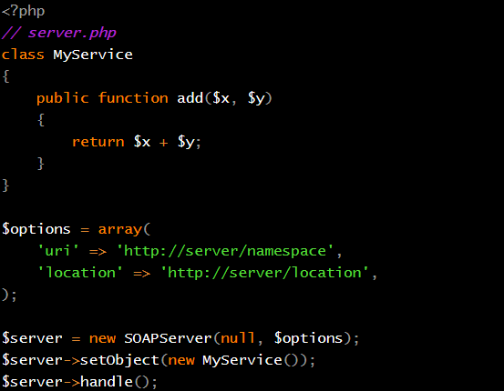

Figure 19 Example of SOAPServer format (Source: <http://www.whitewashing.de>)

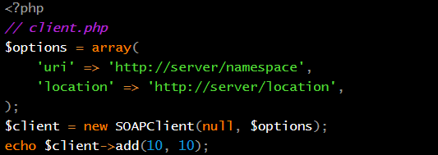

Figure 20Example of SOAPClient Code (Source: http://www.whitewashing.de)

## RESTful

Another major web service is Restful. REST remains for Representational State Transfer, which is an engineering style for arranged hypermedia applications, it is essentially used to manufacture Web benefits that are lightweight, viable, and adaptable, TUTORIALSPOINT (n.d.). An administration in view of REST is known as a RESTful services. REST is not reliant on any convention, but rather verging on each RESTful administration utilizes HTTP as its basic convention. Over 10 years after its presentation, REST has gotten to be a standout amongst the most essential innovations for Web applications. Its significance is liable to keep becoming rapidly as all advancements move towards an API introduction. Each significant advancement dialect now incorporates structures for building RESTful Web administrations. All things considered, it is critical for Web designers and engineers to have an unmistakable comprehension of REST and RESTful administrations.

Extensive focus is given on resources and access to these resources. Any format can be utilized to represent the resources as unlike SOAP, REST does not has restriction of format selection (Vaqqas, 2014). For instance, programmer can choose JSON or XML based on their requirement.

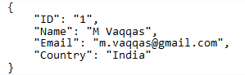

Figure 21Representation of Resource using JSON (Source: [www.drdobbs.com](http://www.drdobbs.com))

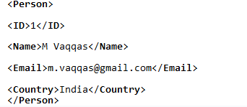

Figure 22Representation of Resource using XML (Source: www.drdobbs.com)

According to IBM (n.d.) RESTful services demonstrates four fundamental principles as follows:

1. HTTP methods are used explicitly
2. Support XML, JSON or both
3. Stateless
4. Directory structure like URLs are exposed

One of the key qualities of a RESTful Web administration is the express utilization of HTTP routines in a way that takes after the convention as characterized by RFC 2616. HTTP GET, for occurrence, is characterized as an information creating strategy that is proposed to be utilized by a customer application to recover an asset, to get information from a Web server, or to execute an inquiry with the desire that the Web server will search for and react with an arrangement of coordinating assets. POST is utilized to create a resource, GET is utilized to retrieve the resource, PUT is utilized to modify the state of resource and finally, Delete is utilized to delete resource.

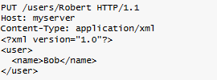

Figure 23 Example of Use of HTTP PUT (Source: [www.IBM.com](http://www.IBM.com))

## Benefits of RESTful Web services over SOAP (Javapoint, n.d.)

1. Due to absence of strict specification in RESTful web service, it is faster than SOAP and it requires lesser amount of bandwidth and resource.
2. RESTful is platform and language independent which means it can be written in any language and can be executed in any operating platform.
3. It can support different resource representation such as XML, JSON, HTML or plain text.

# MySQL 5.5

## Strengths of MySQL 5.5 compared to older versions

According to Dev Dot MySQL (n.d.) following features are demonstrated in MySQL 5.5.

* Improvement in scalability and performance: Multi-core scalability improved
* Enhancement in Solaris support: Improved operation of MySQL server in Solaris
* Monitoring and diagnosis support: Better access to execution and performance information
* Pluggable authentication: Server can use plugins to authenticate clients
* IPv6 Support: Supports clients with IPv6

## Limitations of MySQL

With many benefits MySQL such as open source, easy to setup, great support with PHP, It also has its own weaknesses. Limitations exhibited by MySQL database system is listed here below based on the article in TECHTARGET (n.d.).

* Custom data type storage is not supported by MySQL which is supported by many other database system
* MySQL has not supported direct processing of XML data, which many other database system has already supported
* Stored procedure and trigger are finally supported in version 5 but has yet to be matured
* Only SQL command based interface

## Toad™ for MySQL

To overcome the limitation of MySQL, third party freeware can be utilized. Toad™ for MySQL is a freeware development tool that empowers developers to rapidly and productively make and execute inquiries, mechanize database object administration, and create SQL code, Dell (n.d.). Toad MySQL gives utilities to analyze, separate, and hunt down objects. Tool additionally empowers developer to record and play back console charges, and exchange information crosswise over MySQL databases. The MySQL designer apparatus expands proficiency by offering you some assistance with managing ventures, import/trade information, and control the database. Some of the key and fundamental features of Toad for MySQL are provided below.

* Version Control Integration
* Security Manager
* SQL Editor
* Schema Browser
* Database Browser
* Import and Export etc.

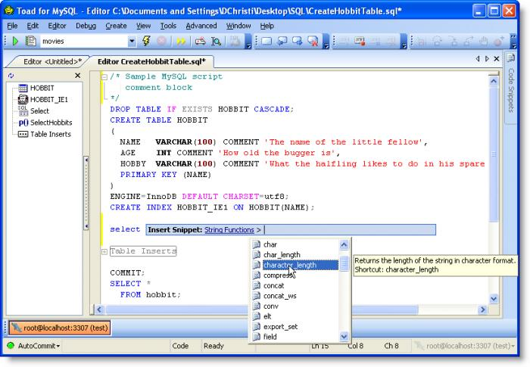

Figure 24 TOAD for MySQL Interface (Source: http://screenshots.en.sftcdn.net/en/scrn/)

# Secure PHP Programming

## $_Get and $_Post

A web program speaks with the server commonly utilizing one of the two HTTP (Hypertext Transfer Protocol) systems — GET and POST. Both strategies pass the data diversely and have distinctive focal points and detriments, as depicted beneath here.

## $_GET

In GET strategy the information is sent as URL parameters that are normally strings of name and esteem sets isolated by ampersands (and). All in all, a URL with GET information will resemble this:



Figure 25 Example of GET method (Source: http://www.tutorialrepublic.com)

The intense parts in the URL are the GET parameters and the italic parts are the estimation of those parameters. More than one parameter=value can be implanted in the URL by linking with ampersands (and). One can just send straightforward content information by means of GET technique. There is a fundamental weakness exhibited by GET method. TUTORIALREPUBLIC (n.d.) notes, the GET system is not suitable for passing touchy data, for example, the username and secret key, in light of the fact that these are completely noticeable in the URL question string and possibly put away in the customer program's memory as a went by page.

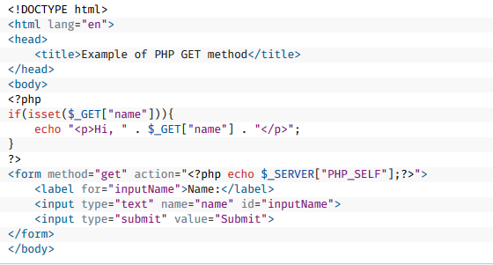

Figure 26 Example of use of $_Get method (Source: http://www.tutorialrepublic.com/)

## $_POST

In POST technique the information is sent to the server as a bundle in a different correspondence with the preparing script. Information sent through POST system won't obvious in the URL, shodor (n.d.). This technique is more secure option than $_GET as user information is not visible in string URL and in logs. Example of $_POST is provided below.

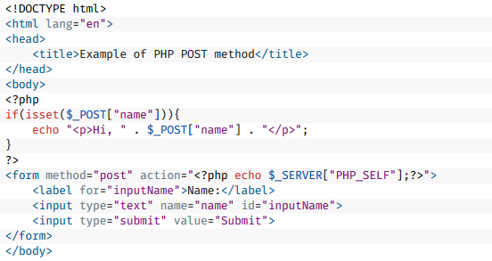

Figure 27 Example of use of POST (Source:http://www.tutorialrepublic.com/)

## Use of Framework

PHP framework is collection of PHP script class that is built for PHP programmer who wants simple and elegant tools to develop complete web application. There are number of framework available in the market. Some of the most popular frameworks being YII, cake PHP, code igniter etc. Using suitable framework is one of the great way to improve PHP security. One of the key advantage of utilizing PHP framework over core PHP is it offers incredible security. The vast majority of the system accompanies data sifting instrument for SQL infusion and XSS infusion. For example, according to banshee-php (n.d.) Bhanshee is a great PHP framework built specially to focus security aspects. Some of the key security features of using such frameworks are:

* Several techniques to prevent SQL Injection
* Prevention of cross-site scripting
* Cross-site request forgery prevention

# Limitations of PHP scripting

With constant improvement of PHP scripting language, lesser and lesser limitations are demonstrated by this programming language. With PHP5 and newer versions of PHP, many flexibility limitations such as messy XML support, unreliable HTML output, unfamiliarity with object oriented programming and complex error handling has been greatly addressed and improved. However, there are still some of significant limitations while programming with this programming language. These limitations are listed below here.

1. It is true that learning and creating PHP based application is easy but according to Mah (2009) not everything with PHP is easy to do. Programming .Net based application with in visual studio offers some great tools to improve programming experience. Managing code in visual studio is easier and allows to hide unwanted code with single click (commenting).
2. There are large number of PHP programming frameworks available. Hence it’s very difficult to debug and maintain an application developed by another programmer. If coding standard and best practice is not maintained to be constant, it is very complex to understand the code.
3. While it is very easy to learn PHP, it leads to development of poorly written application. Novice programmers tends to not give enough considerations to security issues and develop insecure application.
4. There are large number of free libraries can be found in internet that new programmers tends to utilize while programming web applications, Williams (n.d.) cited in O’Dell (2010). These libraries helps programmers to achieve their requirements however on the other hand it exposes to crappy or poorly written codes.
5. Addition of goto operator allows programmers to jump to any statement within function. This results messy coding structure.

One of the key limitation of PHP is its easy learning curve. It can serve as advantage over other scripting programming, however new programmers tends to program using inconsistent standard and does not follow best practices. They tends to ignore security measurements making application vulnerable to security and performance issues. Inclusion of goto operator in fifth version of PHP shows there are still serious improvements required in PHP. Though it has advantages as discussed in benefits of PHP section, it leads to inconsistent and poorly written codes.

# References

* [Online] Available: <http://www.programmerinterview.com/index.php/php-questions/php-what-are-magic-functions/> Accessed [1/3/2016]
* Ahsan (2013) *Difference between PHP4 and PHP5* [Online] Available:<https://bdahsan.wordpress.com/2013/12/03/difference-between-php4-and-php5/> Accessed [1/2/2016]
* Anzala (2013) *Access Modifiers in PHP* [Online] Available:<http://www.trustingeeks.com/access-modifiers-in-php/> Accessed [1/2/2016]
* Banshee (n.d.) Banshee, the secure PHP framework [Online] Available: <http://www.banshee-php.org/> Accessed [1/6/2016]
* Bhumi (n.d.) *GoTo statement in PHP* [Online] Available: <http://www.thecreativedev.com/goto-statement-in-php/> Accessed [1/2/2016]
* Dell (n.d.) Toad for MySQL [Online] Available: <http://software.dell.com/products/toad-for-mysql/> Accessed [1/6/2016]
* Dev DOT MySQL (n.d.) What Is New in MySQL 5.5 [Online] Available: <https://dev.mysql.com/doc/refman/5.5/en/mysql-nutshell.html> Accessed [1/6/2016]
* Guidetti (2010) *Understanding and Applying Polymorphism in PHP* [Online] Available: <http://code.tutsplus.com/tutorials/understanding-and-applying-polymorphism-in-php--net-14362> Accessed [1/2/2016]
* HACKINGWITHPHP (n.d.) Cookies vs. Sessions [Online] Available:<http://www.hackingwithphp.com/10/1/0/cookies-vs-sessions> Accessed [1/6/2016]
* <http://www.ibm.com/developerworks/library/ws-restful/> Accessed [1/6/2016]
* Hunter (2009) *Polymorphism, Abstract Classes, and Interfaces in PHP* [Online] Available:<https://thomashunter.name/blog/polymorphism-abstract-classes-and-interfaces-in-php/> Accessed [1/2/2016]
* IBM (n.d.) RESTful Web services: The basics [Online] Available:
* ITSPHPTUTORIAL (n.d.) *Access modifiers in PHP* [Online] Available: <https://itsphptutorial.wordpress.com/access-modifiers-in-php/> Accessed [1/3/2016]
* Javapoint (n.d.) RESTful Web Services[Online] Available: <http://www.javatpoint.com/restful-web-services> Accessed [1/6/2016]
* Lassosoft (n.d.) Understanding Cookies and Sessions [Online] Available: www.lassosoft.com/Tutorial-Understanding-Cookies-and-Sessions Accessed [1/3/2016]
* Lornajane (2012) *9 Magic Methods in PHP* [Online] Available: <http://www.lornajane.net/posts/2012/9-magic-methods-in-php> Accessed [1/3/2016]
* Mah, P. (n.d.) *Disadvantages of Web Development Using PHP* [Online] Available:<http://www.itbusinessedge.com/cm/blogs/mah/disadvantages-of-web-development-using-php/?cs=33397> Accessed [1/2/2016]
* Moon, S. (2011) PHP benefits of storing session data in database[Online] Available: <http://www.binarytides.com/php-benefits-of-storing-session-data-in-database/> Accessed [1/3/2016]
* Muse, B. (2010) When to use Session vs cookies [Online] Available: buildinternet.com/2010/07/when-to-use-_session-vs-_cookie/ Accessed [1/3/2016]
* O’Dell, J (2010) 8 Experts Break Down the Pros and Cons of Coding With PHP [Online] Available:<http://mashable.com/2010/11/19/pros-cons-php/#cgSJOeIQFOqW> Accessed [1/2/2016]
* PACKTUB (n.d.) SOAP and PHP 5 [Online] Available: <https://www.packtpub.com/books/content/soap-and-php-5> Accessed [1/6/2016]
* PHP don net (n.d.) *what has changed in PHP 5.0.x*[Online] Available: <http://php.net/manual/en/migration5.changes.php> Accessed [1/2/2016]
* PHPPOINT (n.d.) *PHP Access Modifier*[Online] Available:<http://www.phptpoint.com/php-access-modifier/> Accessed [1/2/2016]
* PHPPOT (n.d.) *PHP Access Modifiers* [Online] Available: <http://phppot.com/php/php-access-modifiers/> Accessed [1/3/2016]
* PROGRAMMERINTERVIEW (n.d.). *In PHP, what are magic methods and how are they used?*
* shodor (n.d.) $_GET, $_POST, and $_REQUEST [Online] Available: <http://shodor.org/~kevink/phpTutorial/nileshc_getreqpost.php> Accessed [1/6/2016]
* Singh, A. (2013) *Abstract Classes and Interface in PHP* [Online] Available:<http://www.techflirt.com/tutorials/oop-in-php/abstract-classes-interface.html> Accessed [1/2/2016]
* Singh, A. (n.d.) *Magic Methods in PHP* [Online] Available: <http://www.techflirt.com/tutorials/oop-in-php/magic-methods-in-php.html> Accessed [1/3/2016]
* Smith, T (2011) *Writing Custom Session Handlers* [Online] Available:<http://www.sitepoint.com/writing-custom-session-handlers/> Accessed [1/3/2016]
* SUNILB (2007) *PHP5 Tutorial OOPS – PHP5 Class Access Specifies – public, private and protected* [Online] Available: <http://www.sunilb.com/php/php5-tutorial-oops-php5-class-access-specifiers-public-private-and-protected> Accessed [1/3/2016]
* TECHTARGET (n.d.) MySQL limitations [Online] Available: <http://searchitchannel.techtarget.com/feature/MySQL-limitations> Accessed [1/6/2016]
* Tizag Dot Com (n.d.) PHP Sessions - Why Use Them? [Online] Available: <http://www.tizag.com/phpT/phpsessions.php> Accessed [1/3/2016]
* Trachtenberg (2004) *Why PHP 5 Rocks*[Online] Available: <http://www.onlamp.com/pub/a/php/2004/07/15/UpgradePHP5.html> Accessed [1/2/2016]
* TUTORIALREPUBLIC (n.d.) PHP GET and POST [Online] Available: <http://www.tutorialrepublic.com/php-tutorial/php-get-and-post.php> Accessed [1/6/2016]
* TUTORIALSPOINT (n.d.) RESTful Web Services Tutorial [Online] Available: <http://www.tutorialspoint.com/restful/> Accessed [1/6/2016]
* Vaqqas, M. (2014) RESTful Web Services: A Tutorial [Online] Available: <http://www.drdobbs.com/web-development/restful-web-services-a-tutorial/240169069> Accessed [1/6/2016]
* W3School (n.d.) PHP 5 Sessions[Online] Available: <http://www.w3schools.com/php/php_sessions.asp> Accessed [1/3/2016]
* Whitewashing (n.d.) SOAP and PHP in 2014 [Online] Available: <http://www.whitewashing.de/2014/01/31/soap_and_php_in_2014.html> Accessed [1/6/2016]

# Task 5 for D2

## Fact finding Technique (Pre Enquiry FAQ)

To understand the business requirement of the system, various fact finding techniques are required to be utilized. For this project, interviews with organization managers, staffs and IT administrators is taken. Questions asked during interview are provided below.

## Frequently Asked Question during Fact finding

1. What are the basic features you want in new system?

**Analyzed Answer**: Allow clients to view, add to cart and purchase products of different brands and allow admin to manage clients, brands and products.

1. What is available budget for the project?

**Analyzed Answer**: Total budget available for project is no more than NRs. one lakh.

1. What is available time for the project?

**Analyzed Answer**: Total time available for planning, designing, implementing and successful deployment is no more than three months.

1. Does organization has existing system that can be upgraded? (Yes/ No)

**Analyzed Answer**: No

1. What platform organization wants to target?

**Analyzed Answer**: Platform independent

1. What delivery method organization wants for the project? (Desktop, web, android)

**Analyzed Answer**: Web

1. What type of ecommerce site organization wants? (transactional, information, e-market)

**Analyzed Answer**: Transactional

1. How many types of brand and product organization can dear with?

**Analyzed Answer**: Unlimited

1. What payment system should be implemented?

**Analyzed Answer**: Cash on delivery

1. Is Google map service is required?

**Analyzed Answer**: No

1. How organization wants to support its clients?

**Analyzed Answer**: Vie support/feedback form

1. Should clients require to login first before adding products to cart?

**Analyzed Answer**: Vie support/feedback form

Questions and analyzed answers after interview enables system analyzed to investigate system requirements and prepare time and cost plans for the project.

# Login Module

**Login.php**

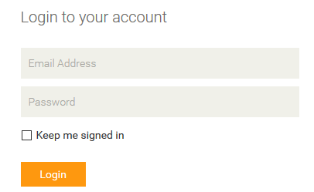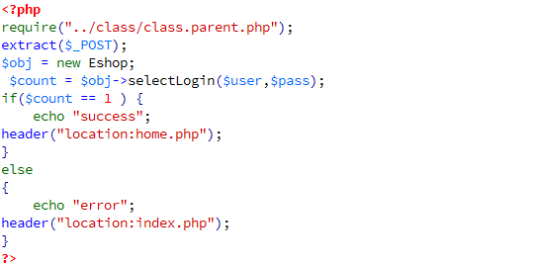

Figure 28 Login Form

# Product Management

## View Products

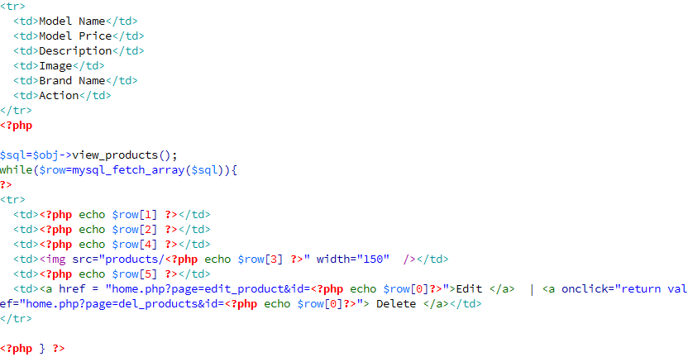

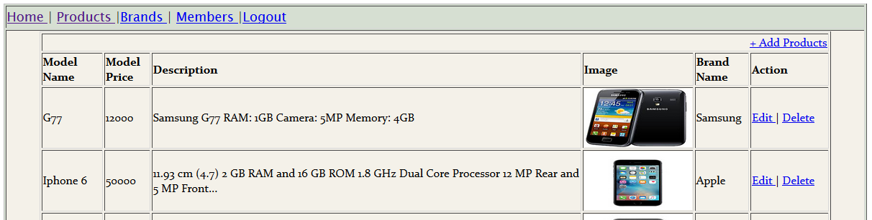

Figure 29View Products

## Drop down in New Product page

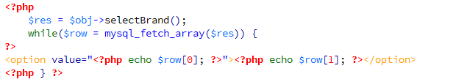

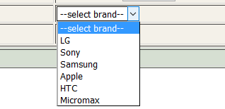

Figure 30 Dropdown Menu

## Delete Products

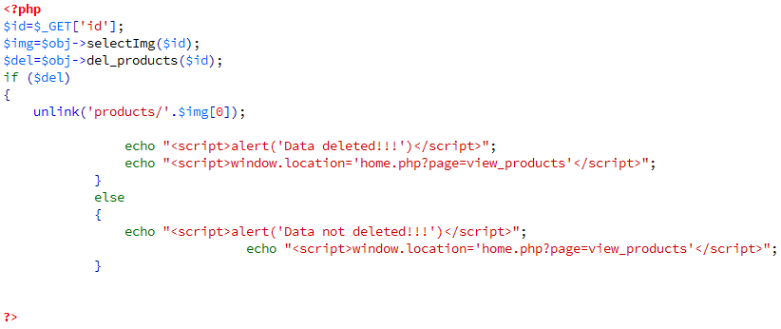

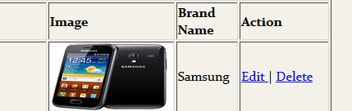

Figure 31 Delete Product

# Brand Management

## View Brands

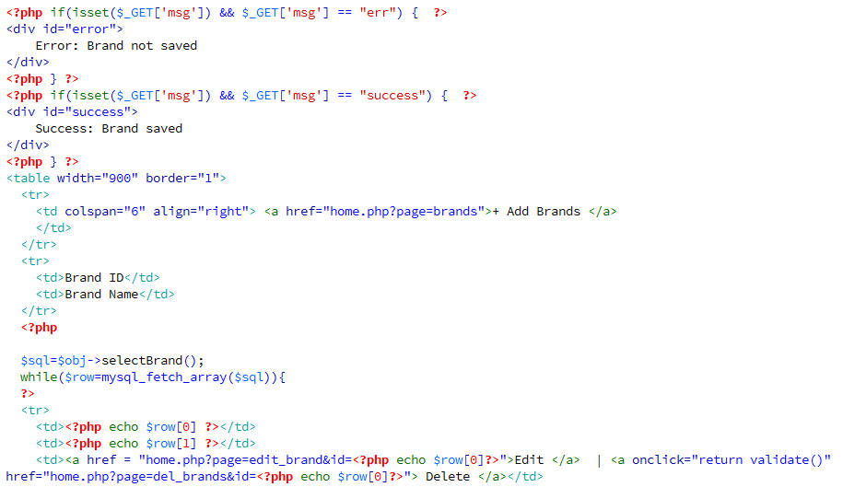

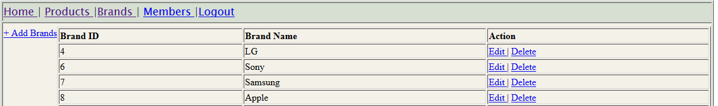

Figure 32View Brands

## Insert Brand

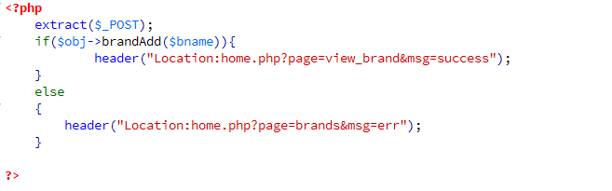

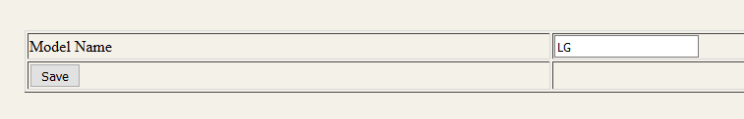

Figure 33 Insert Brand

## Edit Brand

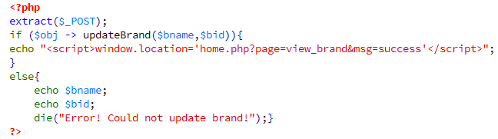

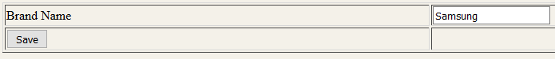

Figure 34 Edit brand

## Delete Brand

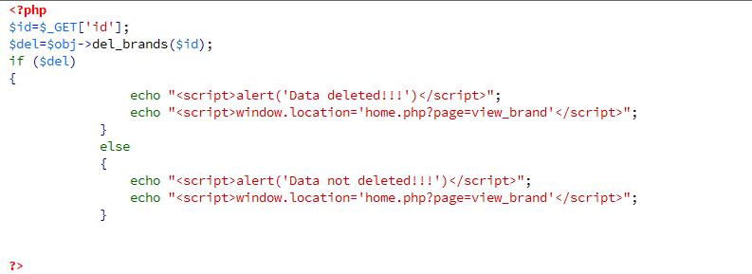

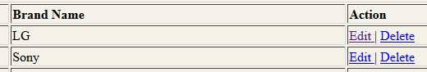

Figure 35 Brand Delete Link

## Image File Uploading

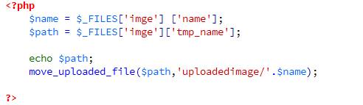



Figure 36File Browsing to upload image

# Member Management

## View Members

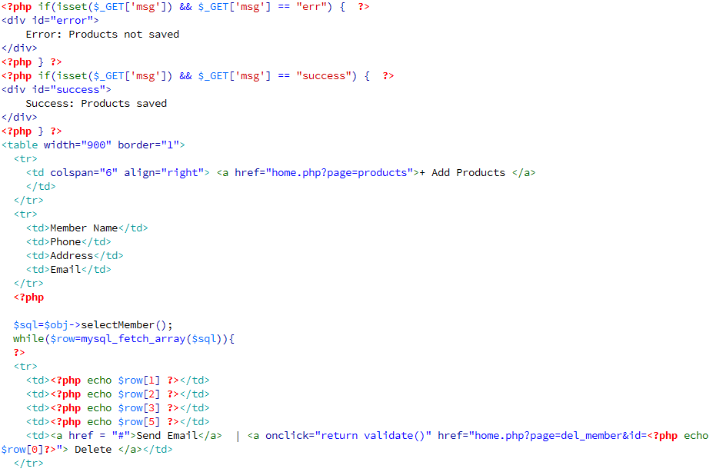

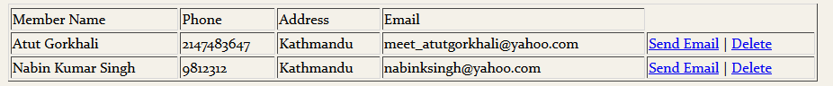

Figure 37View Members

## Delete Member

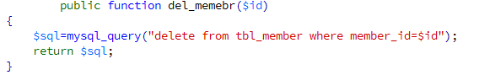

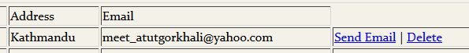

Figure 38Member Delete link

# User Roles

## Sign UP

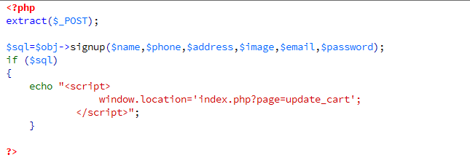

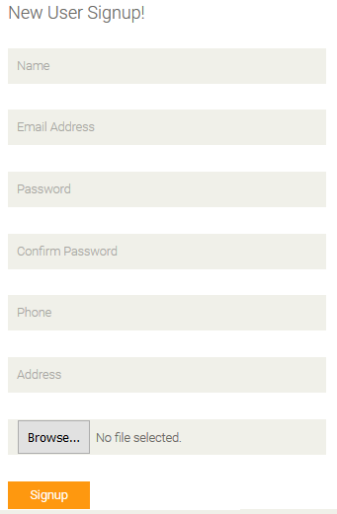

Figure 39Signup form

## Select Product

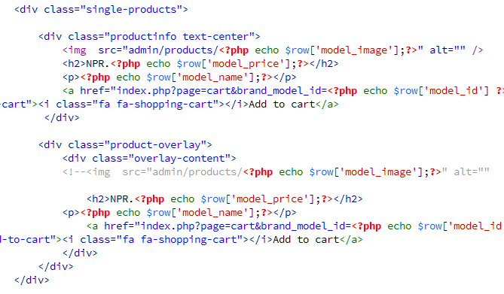

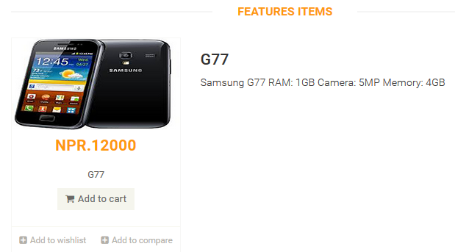

Figure 40 Item Select Detailed view

## Add to Cart

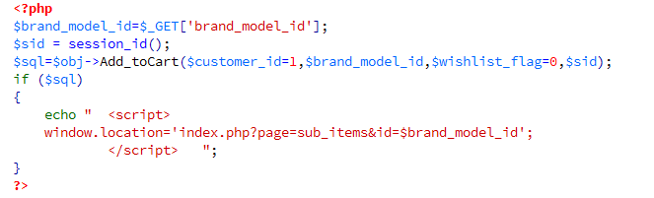

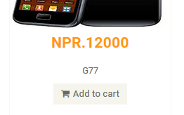

Figure 41Item Add to cart link

## Contact US

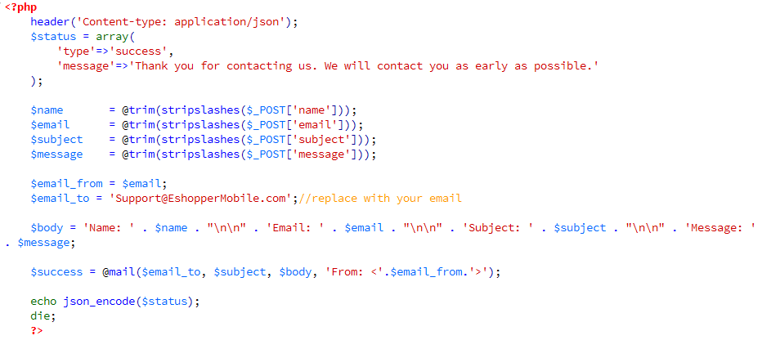

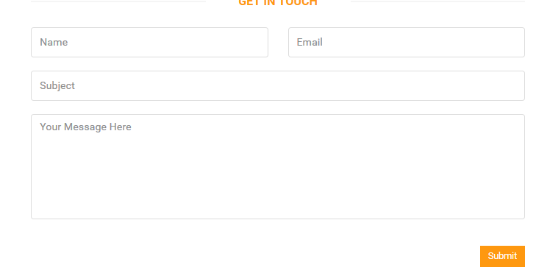

Figure 42Contact Us Form

# Task 8 for M3

# Technical Documentation

## Database system

Database system for online mobile shopping is planned using schema diagram below. Schema diagram is visual illustration of how different objects and attributes of a database demonstrates relationship.

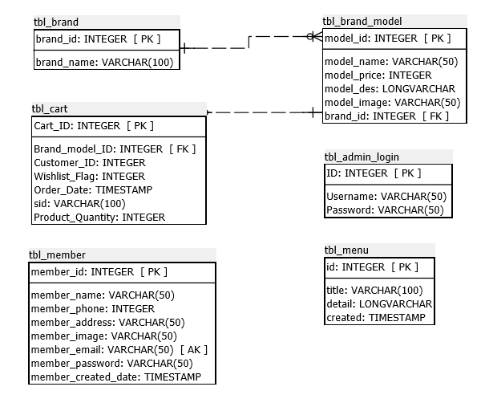

Figure 43 Schema Diagram

Planned database system is implemented using Phpmyadmin, database dictionary of implemented database system is provided below which is prepared using schema diagram above.

## tbl_admin_login

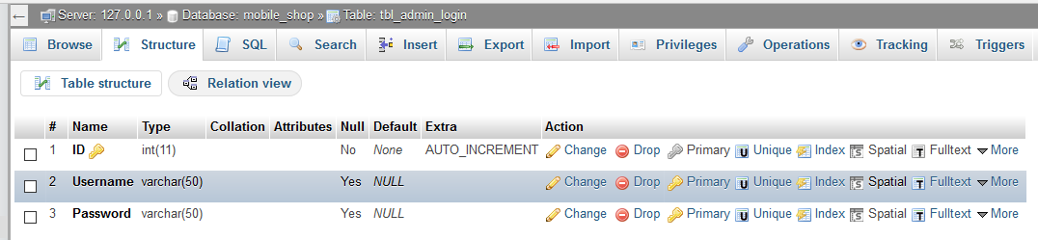

## tbl_brand

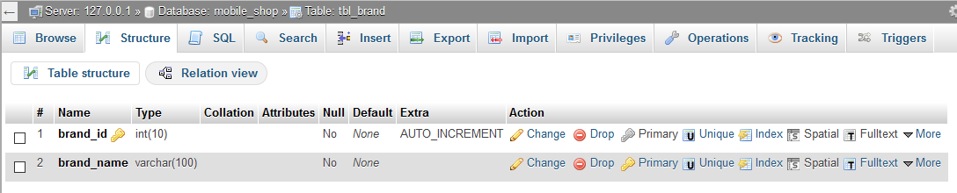

## tbl_brand_model

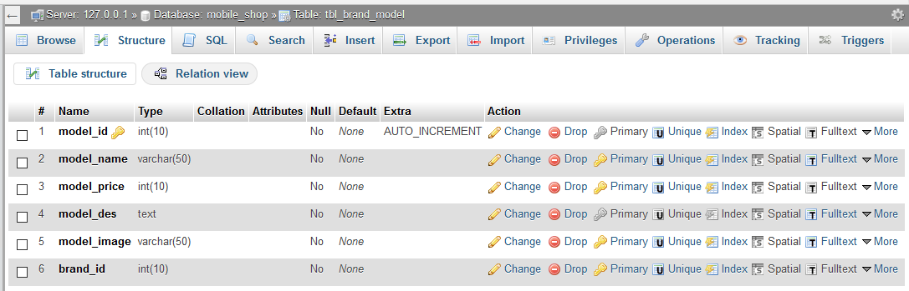

## tbl_cart

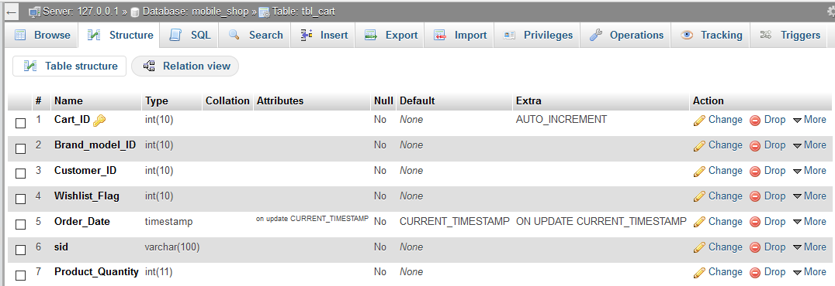

## tbl_member

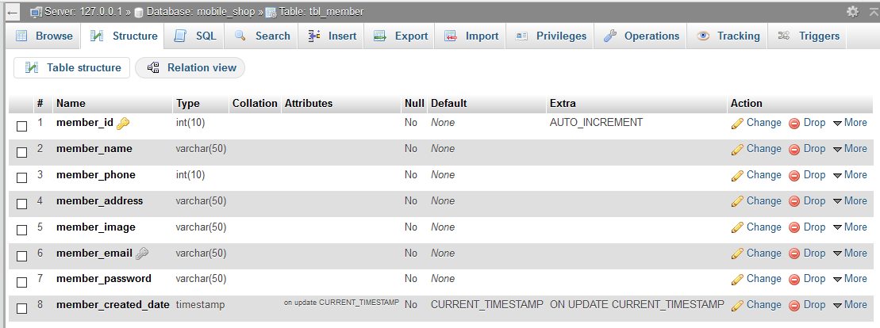

## tbl_menu

